DDR Scoring

Dance Dance Revolution (DDR) is a music-based game series in which the player must press one of four panels on the floor in time with arrows rising up the screen. The DDR series’ scoring mechanisms have evolved over time; in this programming problem, you will implement the scoring system for DDR 3rd Mix.

There are two types of scoring used in 3rd Mix. The first score is the numerical score. Each step is potentially worth a certain amount of points, based on the number of steps in the song, and maintaining a combo throughout the song can boost this value. Let N be the number of steps in the song. The “base step score”, or B, is equal to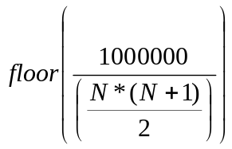, where 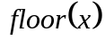 returns the greatest integer less than or equal to x (that is, it rounds down). M is the “step multiplier”, which depends on how accurately the player stepped on the panel. Steps are judged using one of five categories: Perfect, Great, Good, Boo, and Miss. For a Perfect step, M is equal to 10; for a Great step, M is equal to 5; otherwise, M is equal to 0 (i.e., that step is not worth any points). C is the “combo multiplier”. C starts at one. C is incremented after each Perfect or Great step (after the score is calculated); other steps reset C to 1. The score for a given step, denoted S, is then equal to 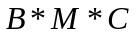. After a step’s score is calculated, it is added to the accumulating score for the song.

On the last step of the song, in addition to the normal step score as detailed above, a bonus is awarded so that the highest possible score (corresponding to getting all Perfects) is approximately 1000000. The bonus, Q, is 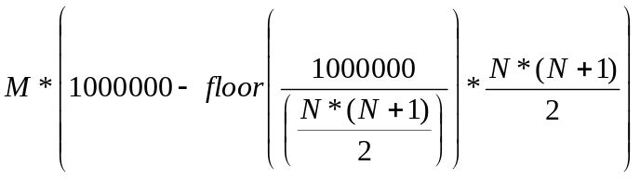, taking M to be the step multiplier for the final step of the song. Note that the combo multiplier does not affect the bonus. (The bonus may sometimes be zero.) The player’s final score for the song is the sum of the scores for the individual steps and the bonus.

The second score partially determines the grade the player is given at the end of the stage. The grade is calculated based on “dance points”, which are added to or removed from a running total based on the player’s performance. The values are as shown in the following table.

Step | Dance Point Value
Perfect | 2
Great | 1
Good | 0
Boo | -4
Miss | -5

After the player’s dance point total is calculated, the player is assigned a grade for the stage. The highest grade, “SSS”, is earned if the player gets all Perfects. The next grade, “SS”, is earned if the player gets at least 80% Perfects and the rest all Greats. If the player gets less than 80% Perfects but the rest all Greats, the player earns an “S”. The other grades are earned based on the percentage of the maximum dance points for the song the player earned, as shown in the following table. (The maximum number of dance points for a song is 2*N, if the player gets all Perfects. Of course, if they earned all Perfects they’d get an SSS instead.) The worst grade the player can earn is “D”.

Percentage | Grade
>= 80% | A
>= 64% | B
>= 50% | C
otherwise | D

(A note to DDR purists: this programming problem assumes that the player passed the song, even if the player would have failed, such as if the player got all Misses.)

In this programming problem, you will implement both scoring methods. You have been given a template source file, DDRScoring.java. The DDRScoring constructor takes an int specifying the number of steps in the song. You will implement the methods with the following signatures:

public int getBaseStepScore() – returns the “base step score” (called B in the description above).

public int getLastStepBonus() – returns the last step bonus (called Q above).

public int addStep(String grade) – grade is one of “Perfect”, “Great”, “Good”, “Boo”, or “Miss”. Returns the current accumulated score after processing this step, including the bonus if this is the final step of the song.

public String getStageGrade() – returns a String containing the player’s grade. This will be one of “SSS”, “SS”, “S”, “A”, “B”, “C”, or “D”.

Here are some sample usages:
In the test given you is an additional example of this method. This example may help you better understand this problem.

This is the only problem that has not been hard coded to pass the given test.

DDRScoring d = new DDRScoring(4);
d.getBaseStepScore(); // returns 100000
d.getLastStepBonus(); // returns 0
d.addStep("Perfect"); // returns 1000000
d.addStep("Great"); // returns 2000000
d.addStep("Good"); // returns 2000000
d.addStep("Perfect"); // returns 3000000
d.getStageGrade(); // returns “C”

